You are given a **directed** graph of n nodes numbered from 0 to n - 1, where each node has **at most one** outgoing edge.

The graph is represented with a given **0-indexed** array edges of size n, indicating that there is a directed edge from node i to node edges[i]. If there is no outgoing edge from node i, then edges[i] == -1.

Return *the length of the* ***longest*** *cycle in the graph*. If no cycle exists, return -1.

A cycle is a path that starts and ends at the **same** node.

**Example 1:**

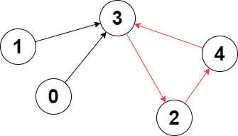

Input: edges = [3,3,4,2,3]  
Output: 3  
Explanation: The longest cycle in the graph is the cycle: 2 -> 4 -> 3 -> 2.  
The length of this cycle is 3, so 3 is returned.

**Example 2:**

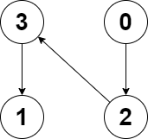

Input: edges = [2,-1,3,1]  
Output: -1  
Explanation: There are no cycles in this graph.

**Constraints:**

* n == edges.length
* 2 <= n <= 105
* -1 <= edges[i] < n
* edges[i] != i